**Assignment 3**

Use the chapter 6 template shown below.

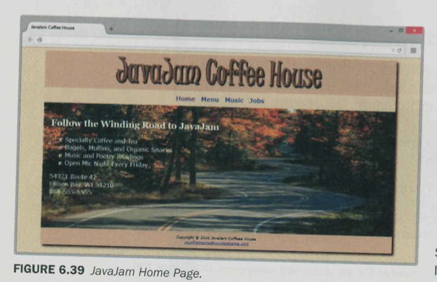

1. Create a multi-level menu only using CSS.

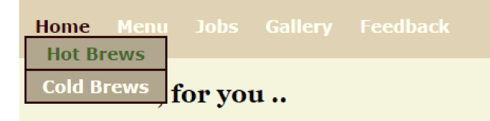

1. In the menu.html, Create a table for menu. Style the table using CSS selectors. Guide for CSS Selectors - <http://www.w3schools.com/cssref/css_selectors.asp>
2. Create an image gallery with hover effects and figure captions. Include this page in your JavaJam website under gallery.
3. Create a job application form. Use the new html5 form elements. Include this page in your JavaJam website under Jobs.
4. Make the website responsive using media queries for devices like IPad(768px) and Smart phones (350 – 365px). Use the below pic as sample. It doesn’t necessarily have to be like this. Use your own creativity.

